Kindergarten Scientists “Get Physical”

in the Panther Pete Science Lab!


All four New Prospect Kindergarten classes visited the Panther Pete Science Lab October 18th & 19th. Students came to the lab to perform some hands-on experiments and investigate the “physical properties” of various items. In support of their current classroom science studies, the students rotated through four centers to observe and test the physical characteristics and composition of many different everyday items.

The purpose of this visit was to explore some key concepts about physical properties such as size, shape, composition, weight and buoyancy.

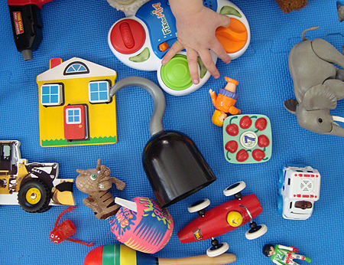

Center 1, “Physical Attributes”: Students were able to sort through a large bin filled with items (including a rubber gorilla!) to find objects with different attributes such as: color, texture, shape, flexibility. Students shared their objects and compared how they were similar and different.

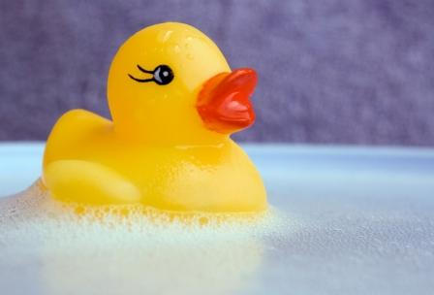
Center 2, “Buoyancy: Sink or Float?” Students worked in pairs to determine the buoyancy of various items by dropping them in containers of water. Sometimes they were surprised at what would float! They learned that an item’s buoyancy is related to its shape, size and weight.


Center 3, “Weight”: In this center, students learned to use balance scales to compare the weight of various objects. They tested the weight of Playdoh vs. clay, softballs vs. baseballs, etc. Students learned that the biggest items weren’t necessarily the heaviest items.


Center 4, “Composition”: Students sorted through a large bin filled with objects of various composition, including items made of wood, plastic, paper, metal, a combination of these materials, and items found in nature (leaves, sticks, shells, etc.) They were able to study and compare these items.

A big thank you to all the parents who volunteered their time to assist our students during this visit! In addition to our lab coordinator, every lab requires at least four parents as science lab volunteers. It is only through their time and dedication that our students get to experience exciting science in action!

A special thanks to our Kindergarten Lab Coordinator, Karen Wilson!

The Kindergarten will visit the Panther Pete Science Lab again in April to study “Plants”.

If you have any questions about the Panther Pete Science Lab, or would like to get involved, please contact Liz Ward (elward74@comcast.net).

